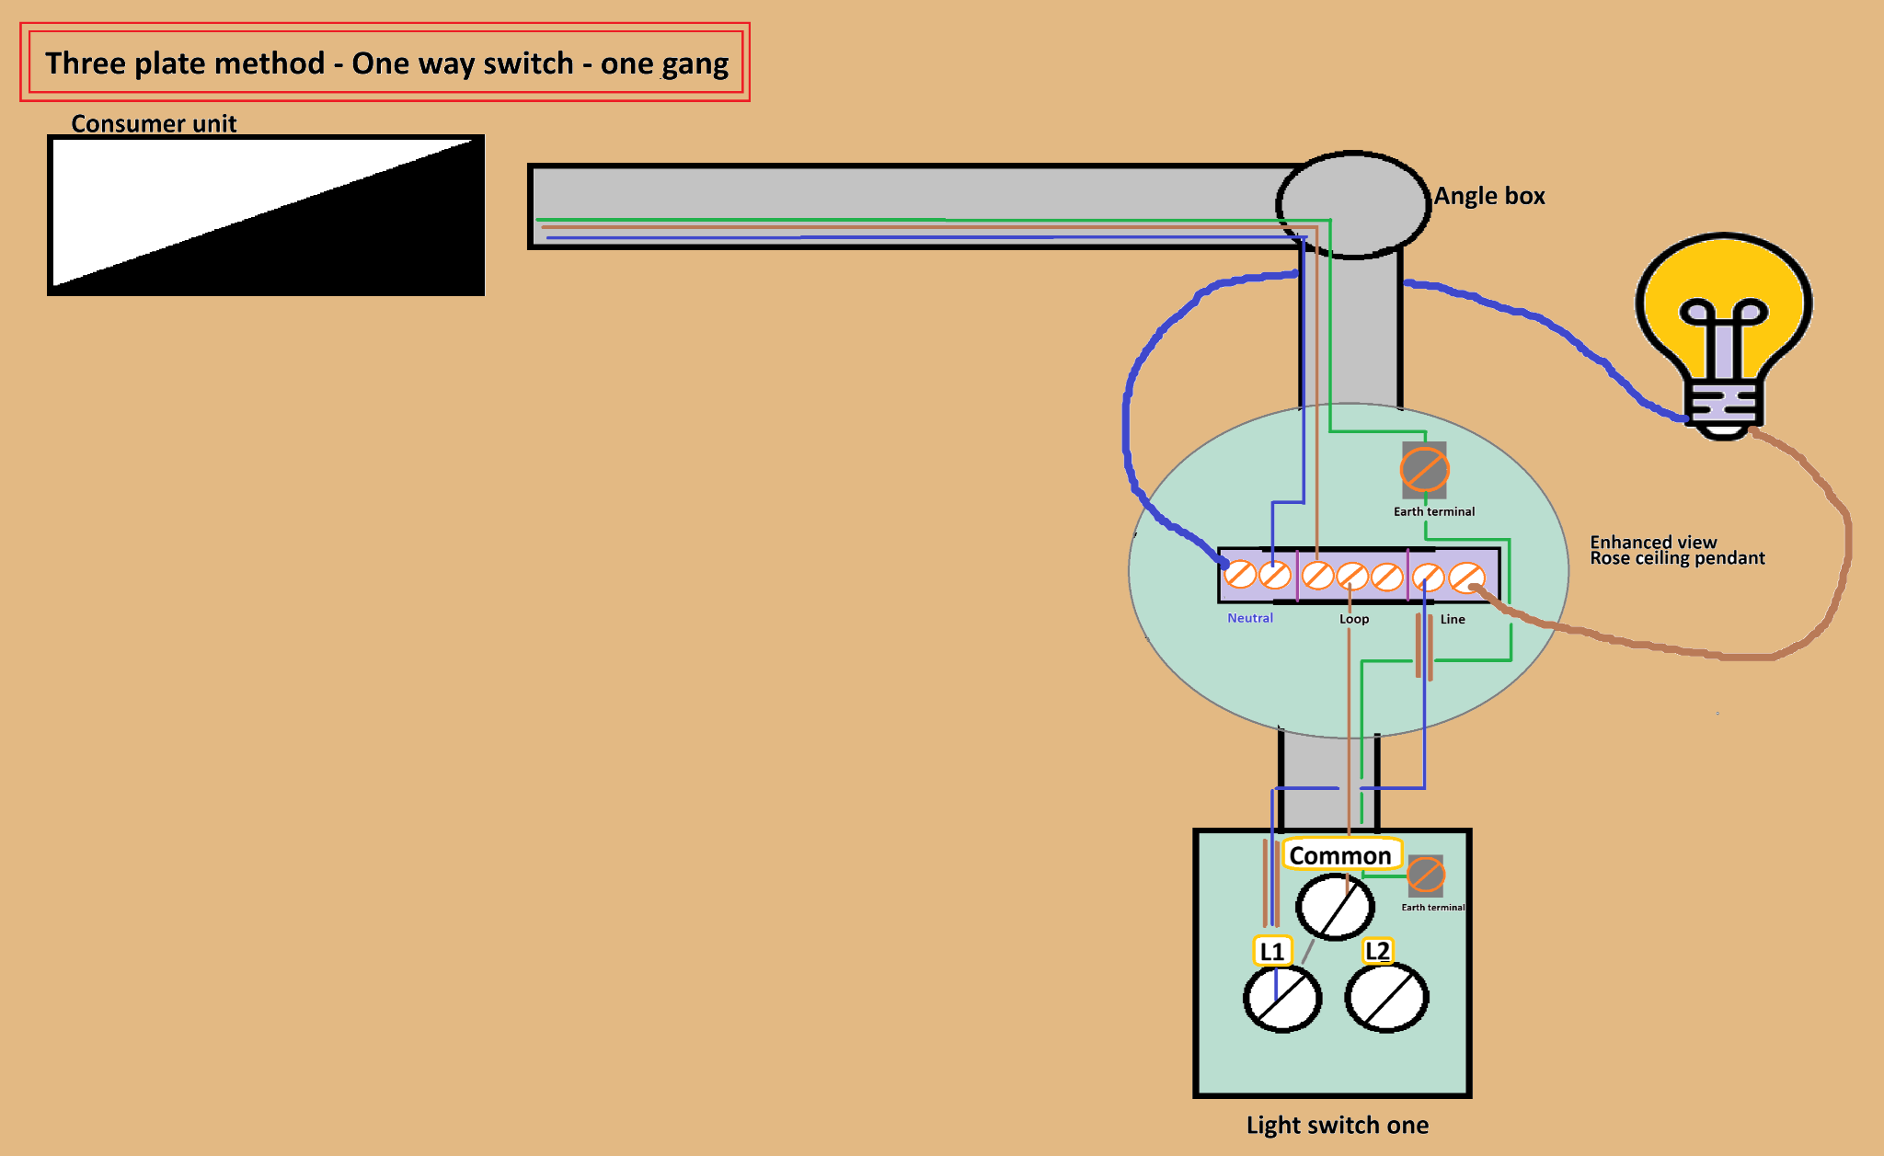

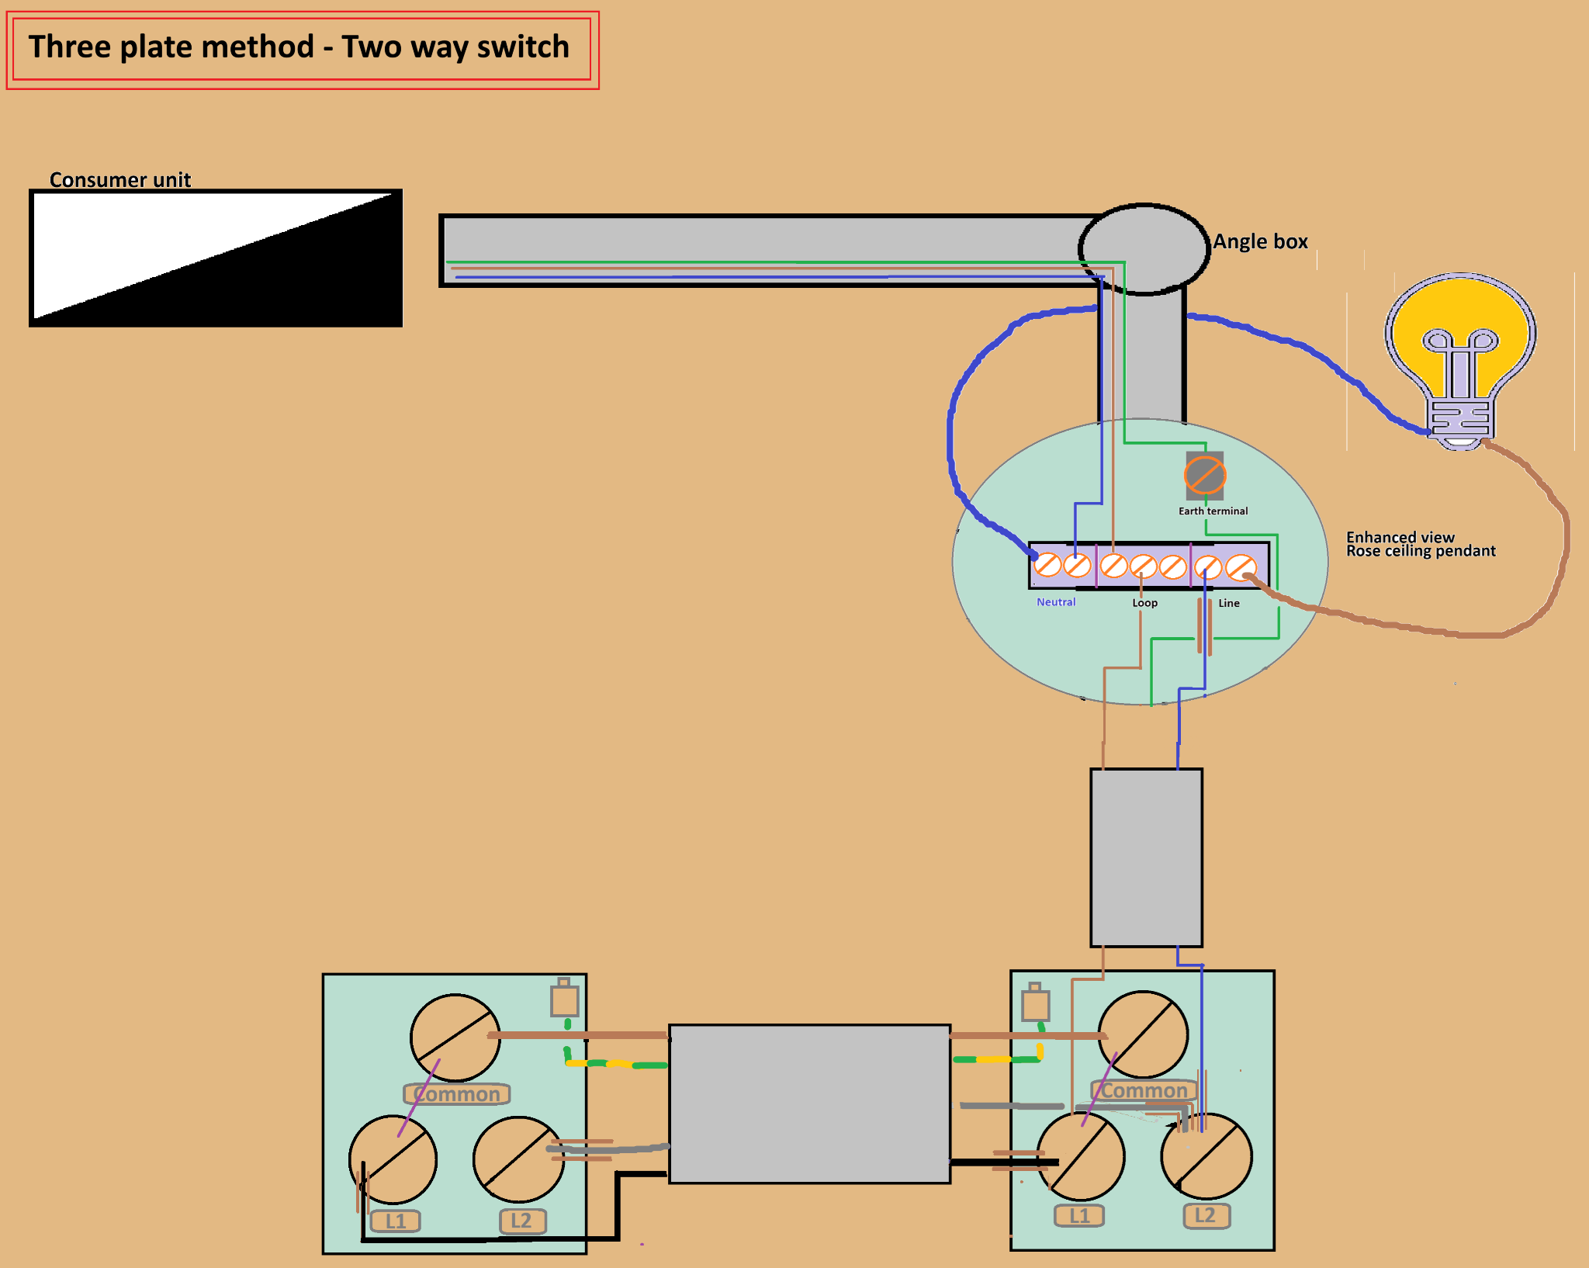

To change a three plate method one-way switch to a three plate method two-way switch

Ceiling cable

The ceiling cable’s brown live wire which was in the common terminal moves to either the L1 or L2 terminal.
Typically, the brown live wire goes into the L2 terminal because the switch-live wire is typically in the L1 terminal.
However, this could not be the case. For example, the switch-live wire could be in the L2 terminal. In which case the brown live wire goes into the L1 terminal.

Strapper cable/ 3 core cable
The three core cable consists of a black wire, brown wire, grey wire and cpc wire.
The strapper cable connects the two light switches together.

The brown live wire of the strapper cable goes into the common terminal. Conveniently, it occupies the place where the ceiling cable’s brown live wire used to be.

Either the grey or black wire can go into the L1 terminal.
Either the grey or black wire can go into the L2 terminal.
The Brown live wire always goes into the common terminal .

